

**USER MANUAL**

**INSTALLATION GUIDE**

**“URGENT WIDGET”**

**Ardy Jaya Putrasalim**

**001201400007**

**April 2018**

# INSTALLATION GUIDE

## System Requirements

Make sure the system meets the following requirements before installation:

* Smartphone that runs Android OS ( ice cream sandwich)
* Able to have app widget (for user)
* Have minimum 50mb memory for the application

## Install the Application

* Make sure the apk file is already downloaded or copied to the phones, one phone for the user and one phone for the officer.
* Run the apk file.

# USER MANUAL

After the installation completed, the application can be run.

## For user

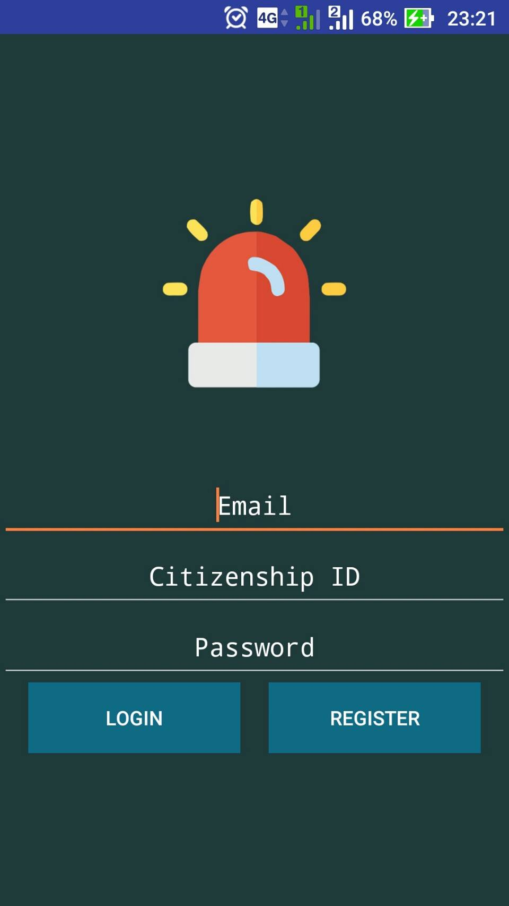1.1 Registration and Login

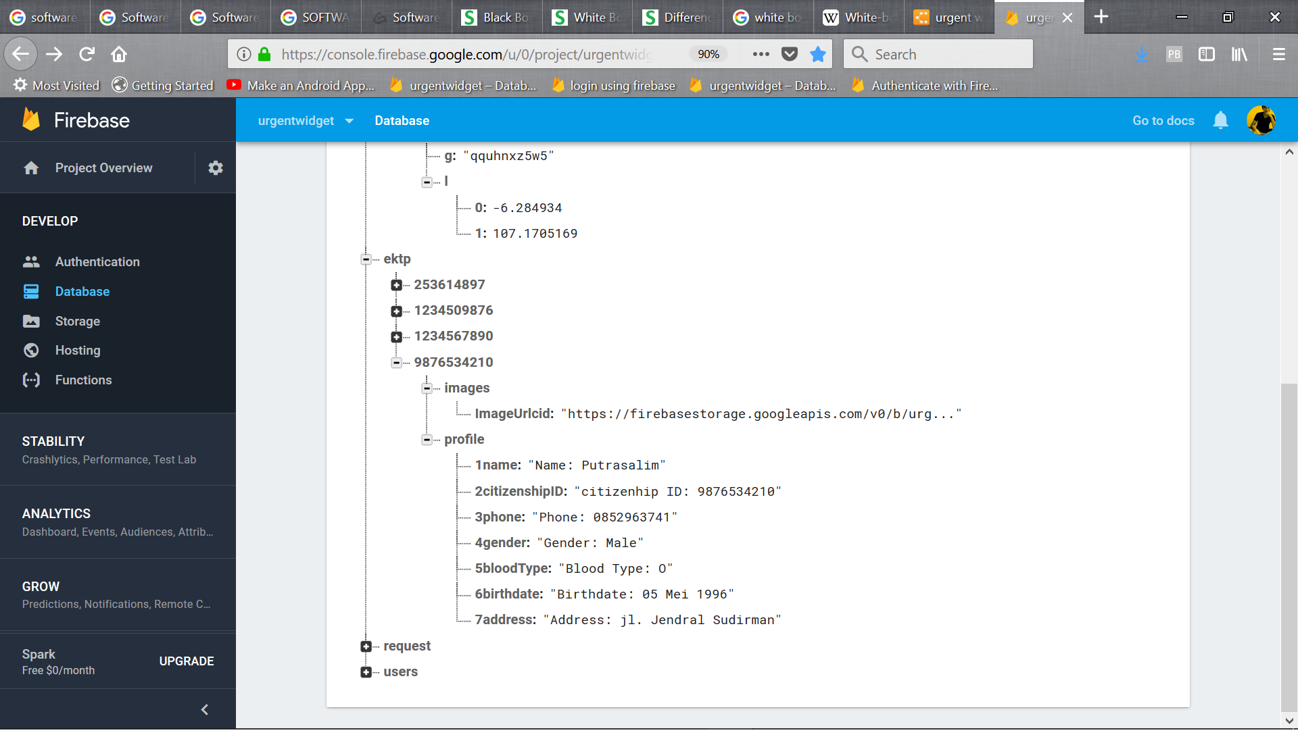 For user registration, can only be done with citizenship ID that listed in the database.

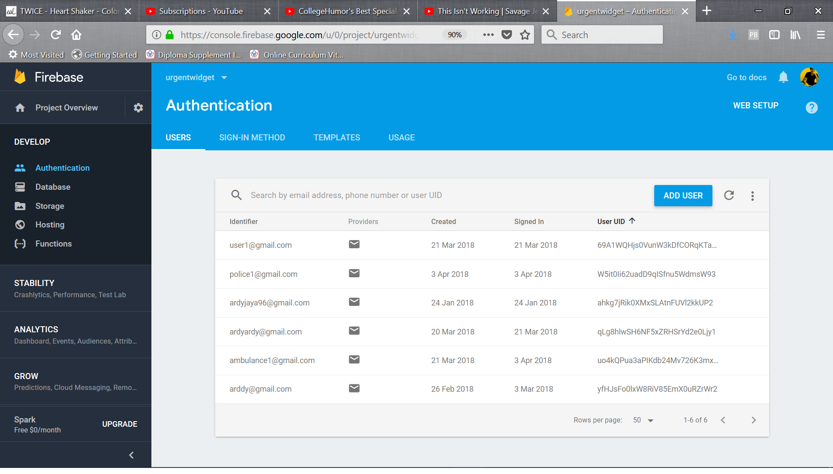For Login, can only be done if the user already registered before.

1.2 Make a request

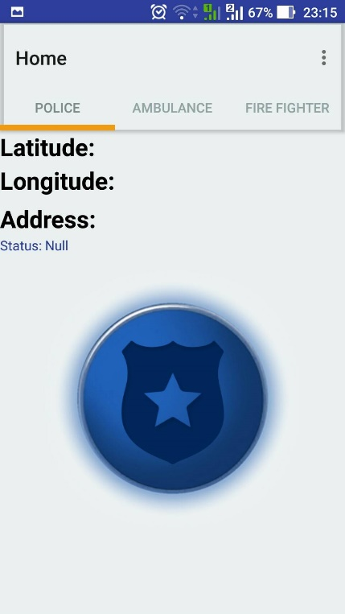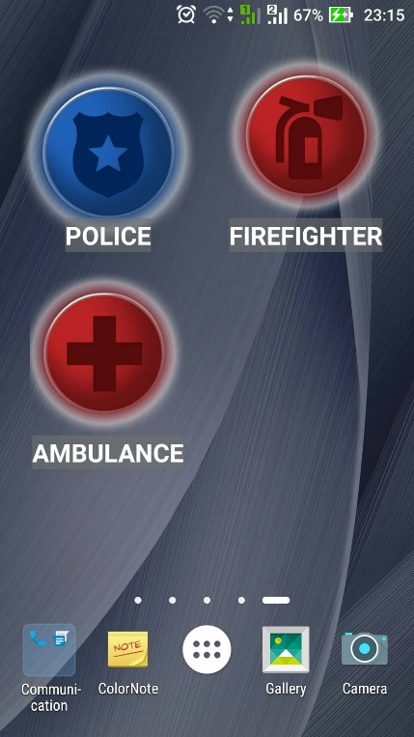To make a request, first user have to enable their GPS location and click the button on the application of from the home screen widget (that placed on home screen by user from the widget menu of the system).

1.3 Menu

From menu bar, user can choose some function like cancel call or update their profile.

1.4 Update profile

After click the update profile menu, user will directed to update page.

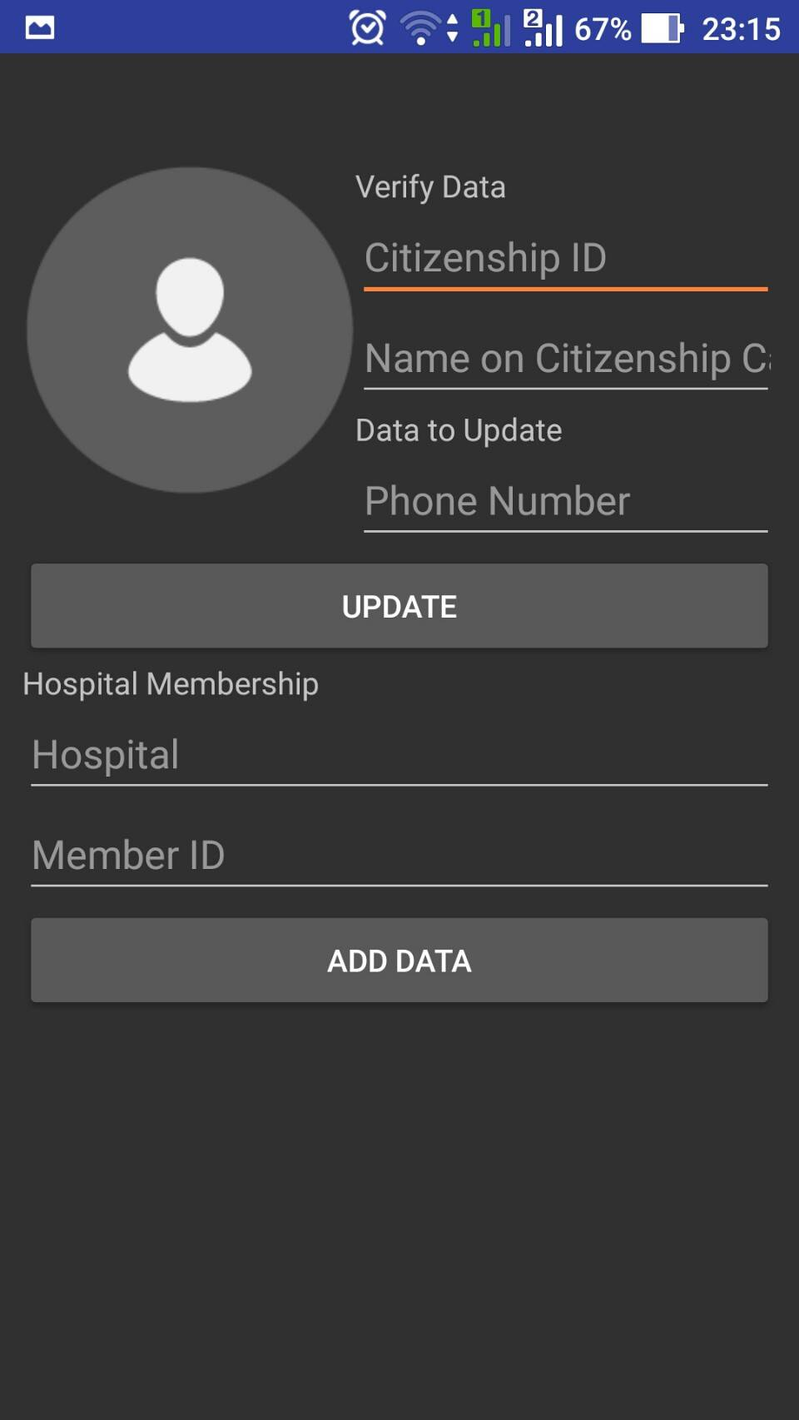Here user can add hospital and patient id data and can change their phone number and profile picture.

## For Officer

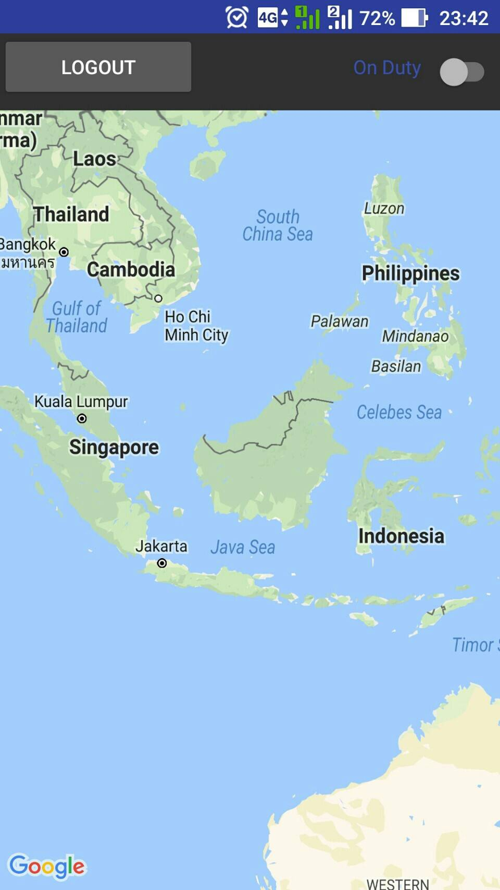2.1 Switch on or off

2.2 Menu button

After the officer paired with user, officer will able to see a menu button where there are some option:

* To show user’s profile
* To complete request